GeochronAtHome macro in Zen Blue

**Step-by-step instructions**

1. ***Set up the microscope***

Start **Zen Blue**. Choose **Zen Pro** and let it calibrate the stage.

1. ***Load the slide into the microscope.***

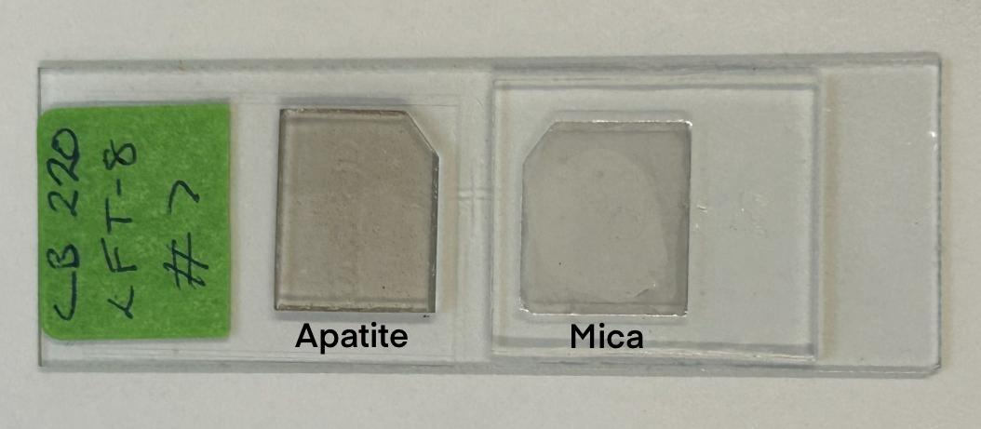

Load the slide in horizontally with the epoxy grain mount with apatite mineral grains on the left and the mica on the right (if using the External Detector method). The epoxy slide is typically about 1mm thick and the mica is very thin.

1. ***Run the GeochronAtHome macro.***

In the **"Macro"** toolbar in the right sidebar (you may have to scroll down to find it), choose “**GeochronAtHome”** and click **Run**. A dialogue appears asking for a project folder. Select a previously used folder or create a new folder for your slide. Each slide requires a separate folder. For your own convenience, naming the folder after the slide will help you find the folder again more easily.

Next, you will see the **"Choose a task"** dialogue. This dialogue gives you a choice between all the different tasks that are available to you at the moment. The list of available tasks will change as you complete previous tasks. Some will also be followed by an asterisk * at the start of their names — these are the **"recommended"** tasks and usually the ones you want to try next.

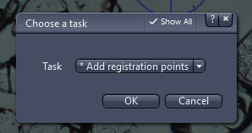

Click the down button and you can see all the currently available options and choose the one you want (unless it is already highlighted, of course).

1. ***Define registration points***

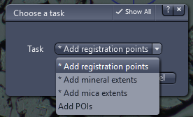

Registration points are used to ensure the location of the slide is consistently defined. This is particularly helpful in avoiding problems caused by re-calibration or slide removal. At least two registration points are needed. They can be two points on the extreme edges of the slide.

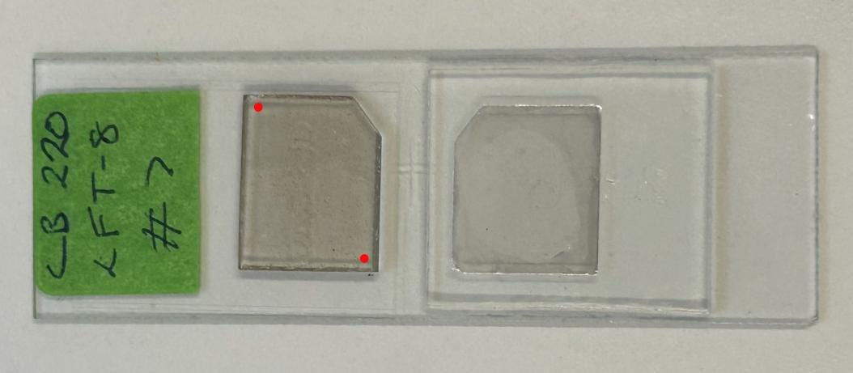

Example of two possible locations of registration points

If you have any registration points, you should choose **"* Add registration points"**. When the registration points are defined, screenshots of those points will be automatically taken.

Click **OK**, and these two boxes appear. Due to the limitations of the macro environment in Zen Blue, two boxes are needed for options. Select your option in the top dialogue box and click on the continue button on the bottom dialogue box to confirm your selection.

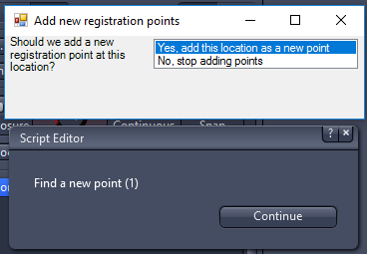

Use the joystick connected to the microscope to move to a registration point. Feel free to change objectives and lighting conditions as much as you like as you try to find the registration points. If there are distinguishing features on the slide such as copper meshes, you may use these as registration points. Otherwise, you can use grains near the edge in more sparsely populated areas as your registration points. It would be helpful to select the centre of a small grain as your registration point.

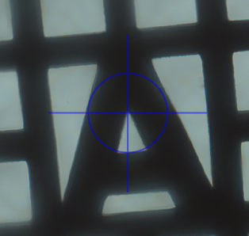

Example of copper meshes

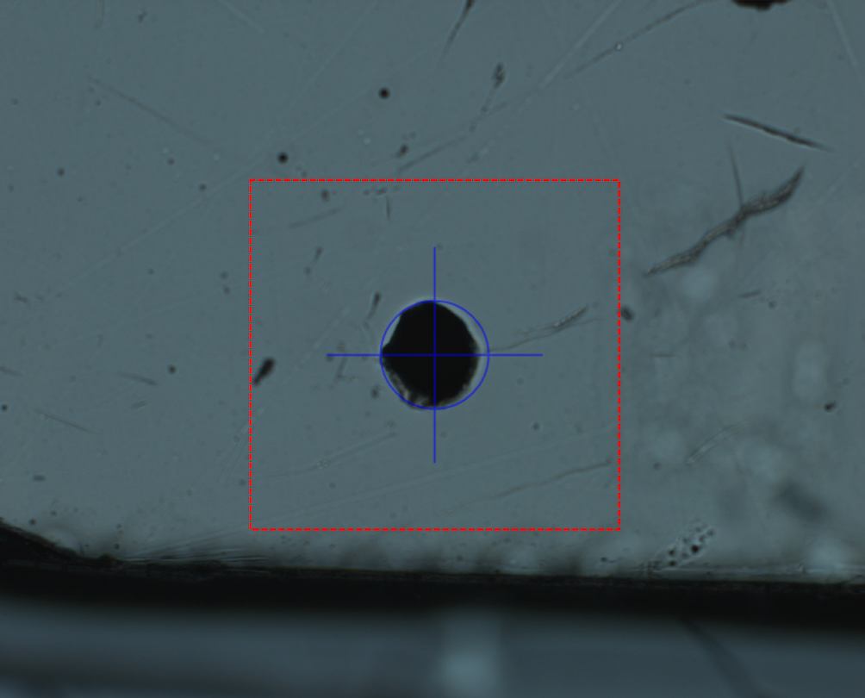

Example of an isolated grain

With **"Yes, add this location as a new point"** selected, click **"Continue"** and the point will be added as a registration point.

For each remaining point, drive to it and click **"Continue"** again.

Once you have finished, click on **"No, stop adding points"** and click **"Continue"**. Next, you will see a new dialogue titled **"Save new registration points?"**. Click **"OK"** and these points will be saved. If you click **"Cancel"** instead, all of these points will be discarded.

If you need to alter your registration points, there are a number of tasks that might help, but it might not be clear how they differ from each other. Here is a description of each one:

**Adjust registration points**: This simply adjusts the registration points through a live microscope image. Nothing else is adjusted. Use this if everything else is in the right place.

**Re-register** (after recalibration or slide removal): This allows you to continue with your project after the microscope has been recalibrated or your slide has moved position for some reason. In this case, all your registration points and POIs look out of place when viewed through the microscope (but they look fine in the **"Add/adjust POIs and registration points (in Manimal)"** task). The screenshots of previously-defined registration points will appear next to the dialogue. The "Re-register" task allows you to choose the current correct position of each registration point and will then adjust the positions of all the POIs to match the new position of the slide (in fact the points are still defined the same, but the difference between the position of the points and their actual position on the slide is noted and taken account of in all subsequent tasks).

**Reset registration**: move points and delete tiled images: Hopefully you will not need to use this task! If all of your POIs and registration points look like they are in the wrong place when you use the **"Add/adjust POIs and registration points (with Manimal)"** task but you think they are correct relative to each other, perhaps this task will save your project. You will need to capture new minerals and mica tiled images after using it. You should never be in this situation if you define your registration points on your first session with the slide and you always re-register after each microscope re-calibration or slide removal.

**4a. *Shut down for the night?***

At any point in this process, if you have defined your registration points you are free to shut down the microscope and/or change the slide. You may return to this slide later, but please remember to choose **"Re-register (after stage recalibration or slide removal)"** as your first task of the next session.

1. ***Define mineral extents***

You now need to define where the minerals are on the slide.

Choose the **"* Add mineral extents"** task (like you chose the "* Add registration points" task above) and, just like you chose the registration points, choose extents for the entire mineral (epoxy) area. **5x to 10x objectives** are suggested for defining mineral extents.

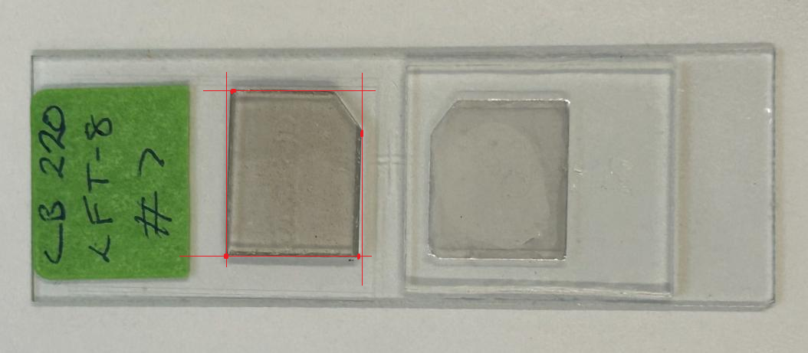Example of selecting extreme points for mineral extents

To define the mineral extent, choose the extreme top, bottom, left and right points on the mineral. This will enable the following steps to capture the entire mineral epoxy slide.

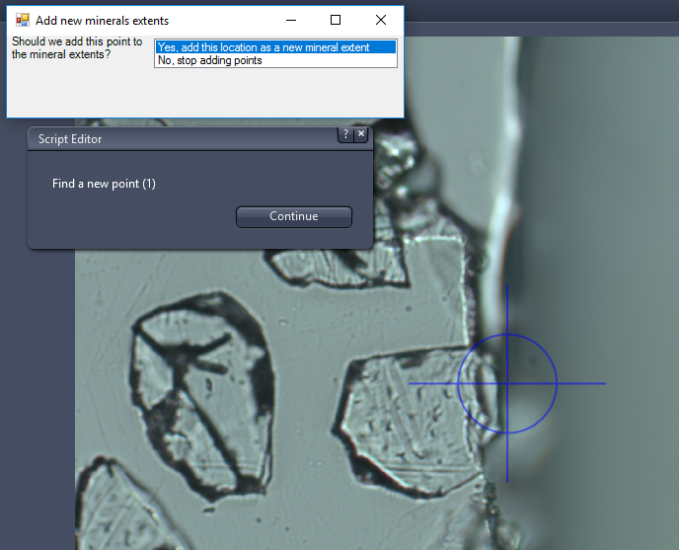

Once again, finish by clicking **"No, stop adding points"**, **"Continue"**, then **"OK"** on the **"Save new mineral extents?"** dialogue box.

1. ***Define mica extents (External Detector method)***

If you are using the External Detector Method and so have a mica to scan, pick **"* Add mica extents"** and follow the method for defining mineral extents, but for the mica.

Micas are located next to the apatite on the slide. The selection of mica extents will be similar to that of mineral extents — selecting points on the extreme edge of the slide.

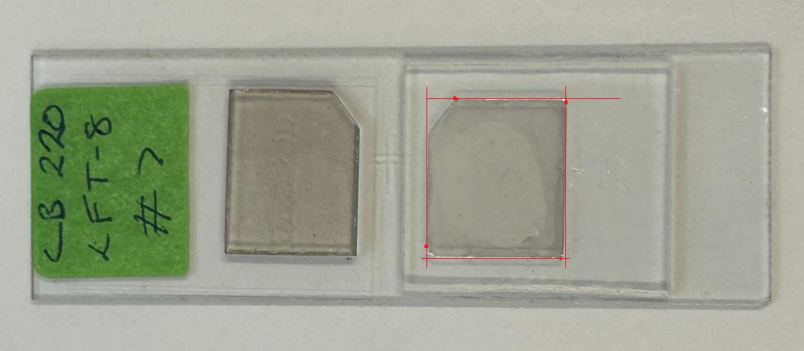

Example of selecting extreme points for mica extents

1. ***Create or adjust mineral focus points***

In order to generate a tiled image that is in focus, you must define some sample points. Choose the "**Create or adjust mineral focus points**" task for this. You will be asked to select the number of focus points you want to define:

You can choose a small number such as 2x2 (recommended for micas because these are flat) to a large number like 5x5 (in case the sample is very far from flat). For the mineral epoxy 4x3 or 4x4 seem to give good results, but feel free to experiment with more points.

Then, you will be automatically driven to points where you will perform a manual focus.

While focusing on the points, it is completely acceptable to move to a slightly different stage position if the current stage position is difficult to focus on. For each point you will also be given the option to ignore points or mark them as unsuitable; these are generally not advisable. Use "ignore" if you moved away from the starting position but now think that was a bad idea; you can run the task again (choosing "Adjust existing points") to have another try. Use "mark as unsuitable" if you really don't want to use this point to focus at all; doing this might make the focus surface much less accurate, though, particularly if it drops the number of points from nine to eight.

If you have already used this task, the option "Adjust existing points" will also be available, to allow you to refocus the points you have already chosen.

1. **Create or adjust mica focus points (External Detector method)**

As for the mineral focus points, choose some focus points so that the tiled image is in focus. 2x2 should be sufficient.

1. ***Generate tiled images***

You will need to generate a tiled image of the minerals and mica (if using the External Detector method). Simply choose **"* Generate minerals tiled image"**. If the **10x objective** is not set, it will prompt you to do it. Please remember to set the condenser correctly. If you do not get this right, you can choose the task again and it will overwrite the old image.

You will be asked to select the lighting you want to use:

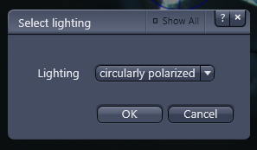

You can choose **"circularly polarized"**, **"transmitted"** or **"reflected"**. You can re-run this task two or three times if you wish to have images captured in different light. You will be able to choose which one looks best when the time comes, but **transmitted light** seems to work the best for our purposes.

If you are using the External Detector Method, please select **"* Generate mica tiled image"** afterwards.

1. ***Define mica transformation (External Detector method only)***

Next you will need to define the mapping between the minerals image and the mica image. This uses a tool called Manimal (short for Manual Image Alignment) which the macro will call for you. Choose the task **"* Get mica transformation matrix (with Manimal)"**.

Manimal will open for you. Feel free to adjust the size of the window (larger is nicer but updates more slowly), and the two brightness controls. When Manimal is open, the Zen Blue programme will say (Not Responding). This is normal and can be ignored.

You can zoom in and out of the image using the mouse wheel.

You can drag the image around using either mouse button. Choose which mouse button you would rather drag the whole image with, and which mouse button you would rather slide the mica with. I prefer the left button for mica sliding, and the right button for image moving, so I click the box labelled **"left mouse button"** and select **"slide"**.

Find a portion of the image with not too many grains, or if you have pin-hole registration marks on mica and minerals, find one of those. Now you are ready to start sliding the mica image to try to align it with the minerals image.

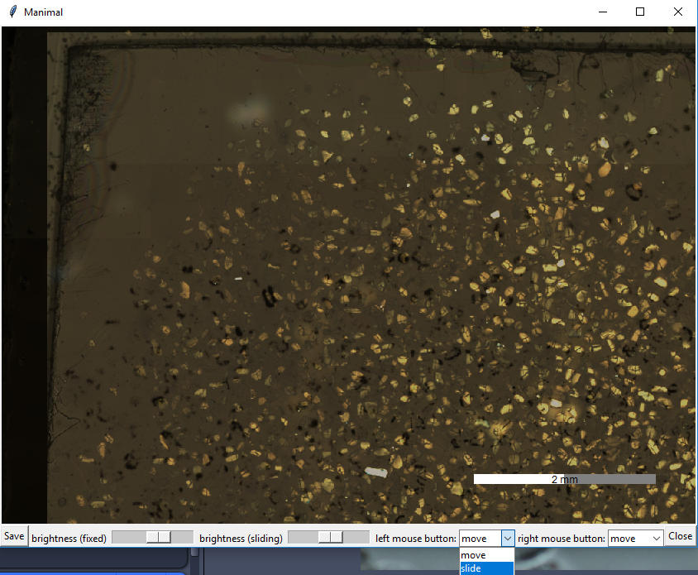

Now you can slide the mica around until at least some grains coincide with their mica equivalents. Now click the **"Pin"** button and click the grain you are most sure is aligned:

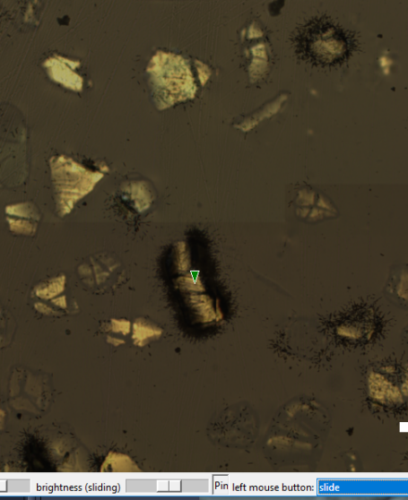

Now your slide button does not translate the mica, but instead rotates it around the pin. Move away from the pin and rotate the mica so that more distant grains line up as well. You are free to reset the pin as many times as you like (click the Pin button a second time to remove it and a third time to put it in somewhere else).

If you chose to capture the minerals image in multiple different lights, Manimal will give you the option to select between them.

Once you are happy with the alignment, click **"Close"**, then **"Save"** in the dialog that pops up.

1. ***Choose Points of Interest***

Now you can choose points of interest using Manimal. Select **"* Add/adjust POIs and registration points (with Manimal)"**. Keyboards are recommended for changing the field of view, or you may miss some points.

It is possible to use the tasks **"Add POIs"** and **"Adjust existing POIs"** instead; these function similarly to the **"Add registration points"** task described above, but they are much less friendly to use.

Choosing **"* Add/adjust POIs and registration points (with Manimal)"** brings up Manimal again, but in a different mode than above. Once again you can adjust brightness with the slider (only one this time as there is only one image), zoom in and out with the mouse wheel, and move around the image by dragging and WASD and arrow keys, but this time the options for changing what the mouse buttons do are different. You now have the options **"Add POI"** and **"Add reg. point"**. Select **"Add POI"** for whichever mouse button you prefer adding your POIs with (you can still use the other to move around the image). Using the WASD and arrow keys, you can scan the slides systematically left-to-right, top-to-bottom.

Now when you click the image with your **"Add POI"** button, **a little white pin** will appear. Use these to mark the grains you would like imaged (in the centre of their countable area). Click as many as you like. If one is in the wrong place, simply drag it around (with either mouse button). To delete one, you can drag it out of the window and it will disappear. I've found that using magnification with the scale bar at **200 microns** works best.

You can also add registration points with the **"Add reg. point"** option, which will let you drop yellow pins as registration points, but you should not need to do this.

Again, when you have finished click **"Close"** then **"Save"** in the dialog that pops up.

For choosing nice grains as your POIs, some examples are demonstrated below as guidance:

|  |  |
| --- | --- |
| A nice grain |  |
| A badly-zoned grain |  |
| A dirty grain |  |
| A grain without good counting area |  |
| A grain that is slightly zoned but with enough counting area |  |
| A grain with track marks |  |
| A zoned grain |  |

Do not worry if you cannot be sure if you want one or not, add as many as you like! You will have the opportunity to mark some as unsuitable in the next steps.

1. ***Validate Points of Interest***

It is a very good idea to validate the POIs you have just chosen, even though the macro does not recommend this action to you. This allows you to centre the grains and ensure that they are in focus.

Select **"Adjust existing POIs"** from the task menu.

The macro will drive to each of your POIs in turn. Feel free to use whichever objective and lighting you want to help determine which POIs are right for you. I prefer **50x** and **Transmitted (non-polarized) light**.

You have four options here:  
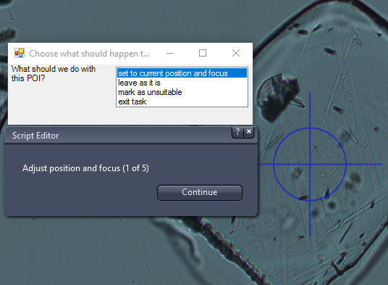

**set to current position and focus**: choose this option if you like the grain. Drive the stage so that the countable area is in the centre of the image and set the focus to be roughly correct before clicking "Continue"

**leave as it is**: Choose this option if you want to keep the grain for now and not move it to your current position and focus. Perhaps you accidentally moved the stage a long way and don't know which grain is the correct one? That's OK, choose "leave as it is" and re-run the "Adjust existing POIs" task again later.

**mark as unsuitable**: Choose this option if you do not like the grain for some reason (not apatite, too cracked, too small a countable area). You will not see this grain again unless you use the "Resurrect unsuitable POIs as suitable" task.

**exit task**: Choose this option to exit the task now. Either because you want to start again from the beginning, or because you have run out of time for today, or because you have chosen enough grains and want to mark all the rest as unsuitable.

If choosing **"exit task"** , you will be given another choice to make, the options here are:

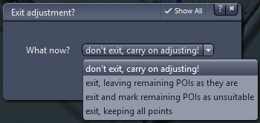

**don't exit**, carry on adjusting! Choose this if you did not mean to exit the task

**exit, leaving remaining POIs as they are**: This is the same as choosing "leave as it is" for all the remaining POIs

**exit and mark remaining POIs as unsuitable**: This is the same as choosing "mark as unsuitable" for all the remaining POIs

**exit**, keeping all points: Choose this if you want to discard all the previous changes you made in this task.

1. ***Validate POIs on the mica (External Detection Method Only)***

If you are using the External Detector Method, you should now run the **"Fine tune mica transformation"** task. Even though this sounds like it only affects the transformation you defined with Manimal above, you will also be given the opportunity to set the focus position for this mica point, and to mark grains as unsuitable based on their image in the mica. For example, some grains that would be suitable for counting were not covered by the mica during irradiation, so you do not see any image of them at all! These are unsuitable.

Run this task and the macro will drive to each POI in turn, take a picture, mirror it and then drive to the equivalent mica image. You can use whichever magnification you like for this task, but it will be much easier to choose the magnification before starting than during, or the mirrored grain image will be at the wrong magnification. 20x seems like a good magnification to choose if in doubt.

You now have the opportunity to adjust the POI's image in the mica. This adjusts the mica positions and focus.

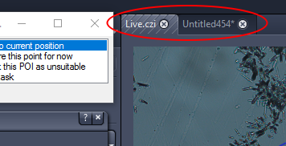

Try to line up the images as best you can and choose **"set to current position"**. If the image is too hard to align, choose **"ignore this point for now"**. If this option is chosen, the algorithm would guess a location and focus for that mica point, but may not be very accurate and may cause problems in the later parts of the process. Choose **"mark this POI as unsuitable"** if the mica image is uncountable.

1. ***Capture Z-stacks***

Finally you can capture Z-stacks! Choose the **"* Capture Mineral Z-Stacks"** task. It will automatically capture all the POIs you have not marked as unsuitable. Both mineral and mica Z-stacks are required to be captured if you are using External Detection Method.

Before capturing a Z-stack you will have the opportunity to specify the number of transmitted and reflected light images you want, and how far apart you want them to be (the default settings are typically good enough:

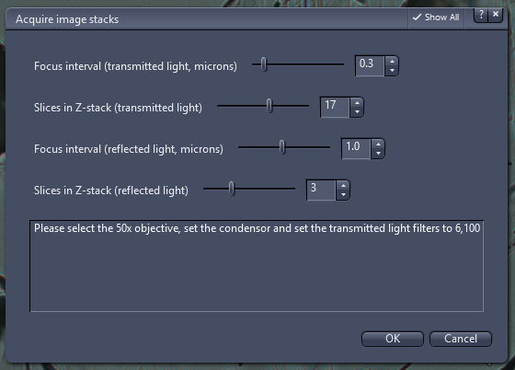

Sometimes autofocus can fail for this task, in which case some POIs will not be captured. If this has happened, the **"* Capture Mineral Z-Stacks"** task will still be available and you can try it again. If it still fails, try running **"Adjust existing POIs"** again (only the POIs that have not been captured will be shown to you) to make sure that the position is correct and the focus is roughly correct. If a grain seems impossible to capture you can mark it as unsuitable.

After you have captured the mineral Z-stacks, you will be given the option to capture their equivalent mica Z-stacks. Choose **"* Capture Mica Z-Stacks for existing Mineral Z-Stacks"** and all the currently-captured mineral z-stacks without mica images will have mica images captured for them.

If this fails, you can try running it again. It might help to focus the microscope on the mica before running the task

1. ***Making a map of the minerals***

If you need to see where the captured Z-stacks are on the slide, you can make a JPG map of it. Choose the **"Create annotated map of minerals"** options. You have a few options:

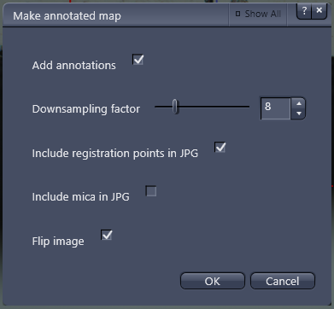

You can untick the **"Add annotations"** checkbox if you only want a JPG of the minerals and don't want any annotations. With the box ticked you will get crosses for each (visible) registration point and a circle for each captured grain. Each circle will itself be annotated with a couple of digits from the GrainNN folder that the Z-stack has been captured to.

You can change the size of the image produced with the "Downsampling factor" control; a lower number produces a bigger image.

By default the registration points will be included in the image, even if they are far apart from the minerals (which could leave a large blank area). If you do not want this, untick the box and you will only see registration points if they are within the minerals area.

If you want the mica included in the image as well, you can tick the "Include mica in JPG" checkbox, but this will not (as the program currently stands) add annotations to the mica.

You can choose between a normal image (that looks like the image seen through the microscope) or a flipped image (that looks like the slide seen in real life).

**Fixing problems**

***Getting POIs back after marking them as unsuitable***

Run the **"Resurrect unsuitable POIs as suitable"** task. It will drive to each POI previously marked as unsuitable. This time the options are:

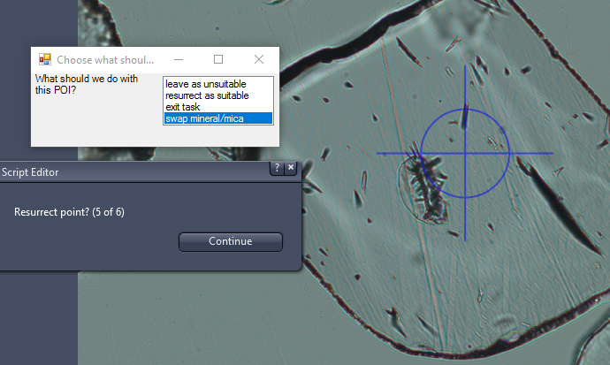

**leave as unsuitable**: If you still believe this POI is not suitable for capture

**resurrect as suitable**: If you believe this was marked unsuitable in error and you would like to capture it (but see swap mineral/mica)

**exit task**: If you want to finish this tool. You will get the option to leave every previously unsuitable POI as still unsuitable (discarding any resurrected POIs), keep the ones you have resurrected but don't resurrect any more, or resurrect all the remaining POIs.

**swap mineral/mica (will only be available if using the External Detector method)**: Before resurrecting a grain, you should examine the corresponding image on the mica. Choosing this option moves to the mica image, or if you are looking at the mica image it returns to the grain. In this way you can check that there is a clear mica image before resurrecting a grain.

***Checking Z-stack images***

Go to the project directory (for example with Windows Explorer) and look at the JPGs in the GrainNN folders.

***Redoing mineral Z-stacks***

If some of the Z-stacks did not come out right, you can delete the GrainNN folder entirely. Then tasks such as **"Adjust existing POIs"** and **"Capture mineral Z-Stacks"** become available. If they are not available immediately, choose "Refresh task list". Then you can adjust the position and focus of the POI with "Adjust existing POIs" and recapture the Z-Stack with **"Capture mineral Z-Stacks"**. It is not possible to replace the mineral Z-stack while keeping the mica Z-stack.

***Redoing mica Z-stacks***

From the GrainNN folder (within the project folder) delete all files starting "Mica", then you should be able to recapture the mica Z-stack.

**Files produced**

The following files are produced by this software:

poi.csv: Registration points, POIs, minerals extents and mica extents

matrix.csv: Transformation matrix from project co-ordinates on the minerals and the equivalent points on the mica

minerals.czi: Tiled image of the minerals portion of the slide (also includes scenes showing the registration points)

mica.czi: Tiled image of the mica portion of the slide

current_reg_matrix.csv: Transformation from project co-ordinates to the current stage co-ordinates (produced by re-registration)

map.czi: Like minerals.czi, but lower resolution and in transmitted light, to turn into map.jpg

map.jpg: an annotated map of the minerals, to show where the z-stacks came from on the slide

Grain<NN>\MicaReflStack-<MM>.jpg: Z-stack of reflected light images of the mica for grain <NN>

Grain<NN>\<XXXX>.jpg_metadata.xml metadata from an image, includes position on stage, exposure time, magnification and so on.

Grain<NN>\MicaStack-<MM>.jpg: Z-stack of transmitted light images of the mica for grain <NN>

Grain<NN>\ReflStack-<MM>.jpg: Z-stack of reflected light images of grain <NN>

Grain<NN>\Stack-<MM>.jpg: Z-stack of transmitted light images of grain <NN>

Grain<NN>\mineral_matrix.csv: registration matrix used at the time of the capture of the mineral Z-stack in this folder (so if you want accurate stage co-ordinates from the metadata, transform by this matrix)

Grain<NN>\mica_matrix.csv: like mineral_matrix.csv but for the mica capture

**Future work**

Possible tasks we do not yet have:

Add/adjust dosimeter points

Capture dosimeter stacks

Other features:

Making the map with a mica image should mark the transformed POIs as well